Part Number: PT925-34180 (D-Cab)

PT925-34182 (C-Cab)

Kit Contents
Item # | Quantity Reqd. | Description
1 | 1 | Left Hand Step Tube
2 | 1 | Right Hand Step Tube
3 | 1 | Hardware Kit
Hardware Bag Contents
Item # | Quantity Reqd. | Description
1 | 16 | SEMS 8mm x 30mm Bolt
2
3
Additional Items Required For Installation
Item # | Quantity Reqd. | Description
1
2
3
Conflicts
Regular/Access Cab Models
Recommended Tools
Personal & Vehicle Protection | Notes
Special Tools | Notes
Installation Tools | Notes
12mm Socket
Ratchet
Torque Wrench | 0-50 N-m (0-37 ft-lbf )
Panel Pry Tool | Toyota SST  00002-06001-01
Special Chemicals | Notes
General Applicability
D-Cab & C-Cab Models
Recommended Sequence of Application
Item # | Accessory
1
2
*Mandatory
Vehicle Service Parts (may be required for reassembly)
Item # | Quantity Reqd. | Description
1
2
3
Legend
STOP: Damage to the vehicle may occur. Do not proceed until process has been complied with.
OPERATOR SAFETY: Use caution to avoid risk of injury.
CAUTION: A process that must be carefully observed in order to reduce the risk of damage to the accessory/vehicle and to ensure a quality installation.
TOOLS & EQUIPMENT: Used in Figures calls out the specific tools and equipment recommended for this process.
REVISION MARK: This mark highlights a change in installation with respect to previous issue.
SAFETY TORQUE: This mark indicates that torque is related to safety.

Care must be taken when installing this accessory to ensure damage does not occur to the vehicle. The installation of this accessory should follow approved guidelines to ensure a quality installation.

These guidelines can be found in the "Accessory Installation Practices" document.

This document covers such items as:-
- Vehicle Protection (use of covers and blankets, cleaning chemicals, etc.).
- Safety (eye protection, rechecking torque procedure, etc.).
- Vehicle Disassembly/Reassembly (panel removal, part storage, etc.).
- Electrical Component Disassembly/Reassembly (battery disconnection, connector removal, etc.).

Please see your Toyota dealer for a copy of this document.

Prepare for the Install.
  - Open the box and check the kit for complete contents and any damage.
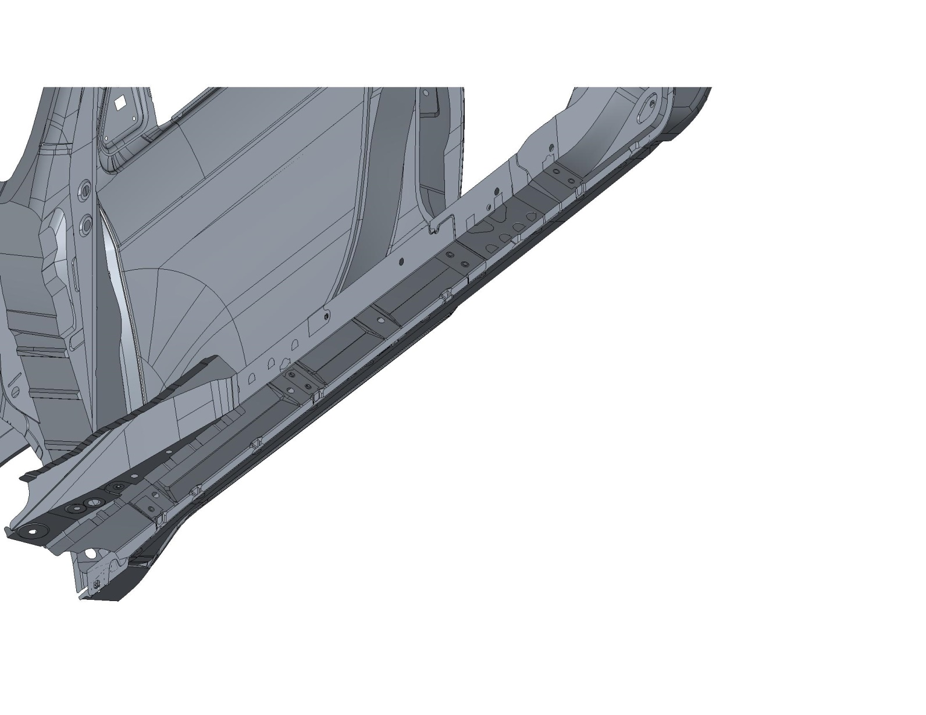
  - Using a 12mm socket, remove & discard sixteen OE Hex bolts from underneath the vehicle, 8 per side (Fig. 1-1).
Fig. 1-1
Bracket mounting locations

Install the Passenger Side Tube Step.
  - Position the tube step to the passenger side of the vehicle (Fig. 2-1).
Fig. 2-1
Front
Center-front
Rear
Center-rear
Passenger side
NOTE: The long bracket goes to the front of the vehicle.
NOTE: For the following steps, the use of a non-impacting type electric hand tool can be used to drive the bolts so long as the bolt does not reach or exceed the specified torque. Leave all hardware loose at this time.
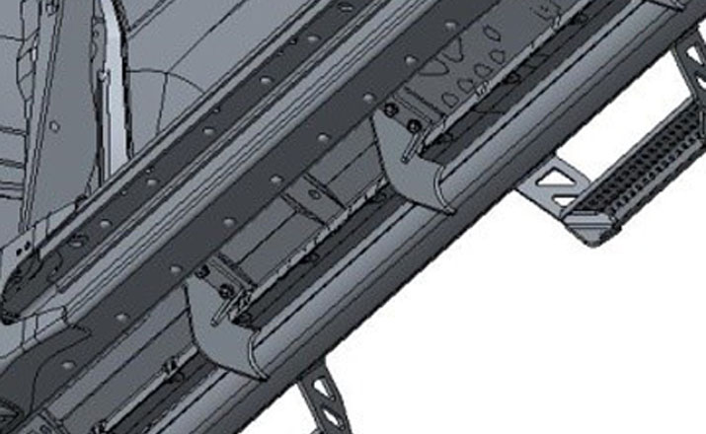
  - Hand start one 8mm bolt into the outside slotted hole in the center-front bracket (Fig. 2-2).
Fig. 2-2
Center-rear outside
Center-front inside
Passenger side
  - Hand start one 8mm bolt into the inside slotted hole in the center-rear bracket (Fig. 2-2).

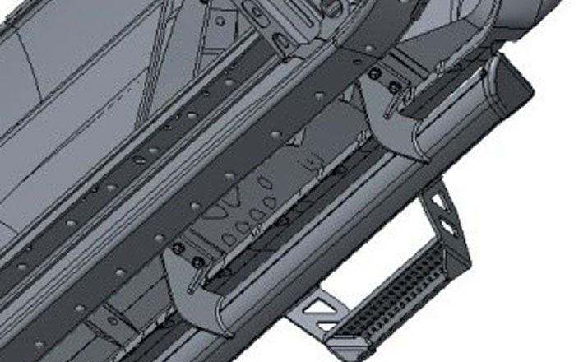
  - Hand start one 8mm bolt into the outside slotted hole in the rear bracket (Fig. 2-3).
Fig. 2-3
Passenger side
Rear outside

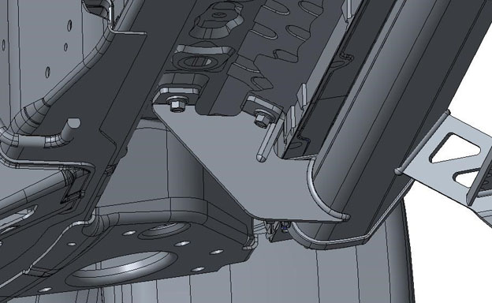
  - Hand start one 8mm bolt into the “outside” hole in the front bracket (Fig. 2-4).
Fig. 2-4
Front outside
Passenger side
  - Hand start the remaining 8mm bolts, starting with the front bracket working to the rear.

Tighten all of the Hardware.
  - In numerical order, tighten (but do not torque) the bolts from the outside bolts (closest to the pinch weld) to the inside bolts shown in Fig. 3-1.
Fig. 3-1
Passenger side
Front
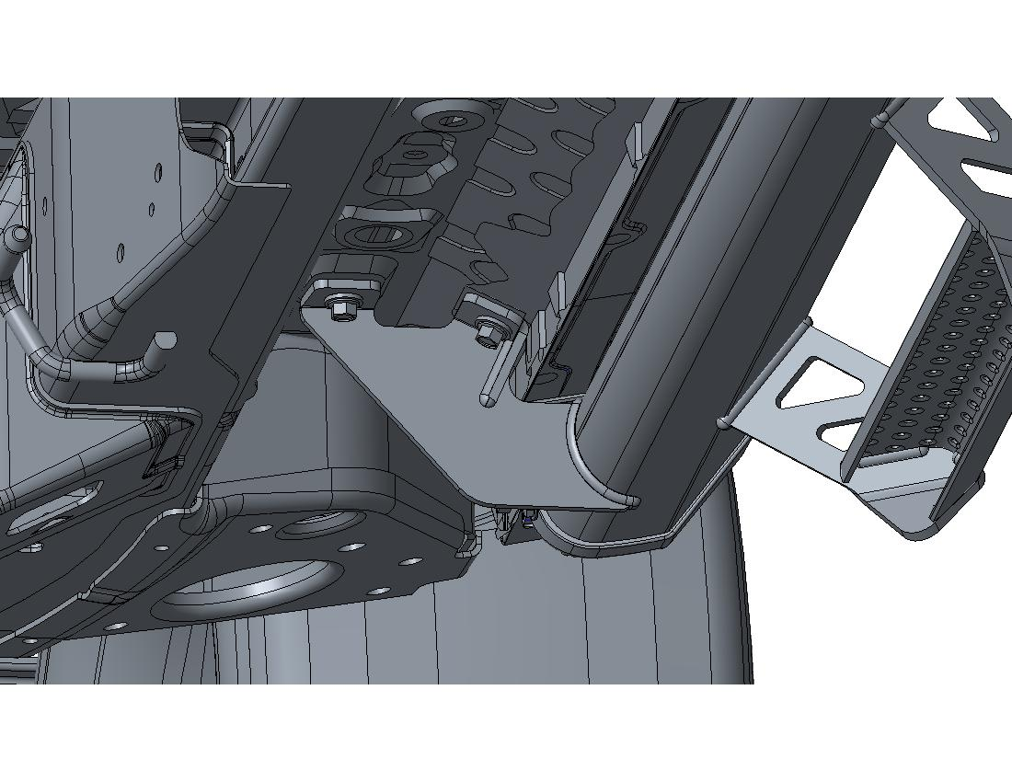
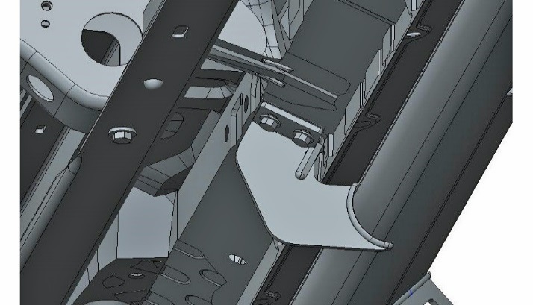
NOTE: As the bolts closest to the pinch weld are tightened, push the bracket inward to maximize clearance to the pinch weld (Fig. 3-2 & Fig. 3-3).
Push as the bolts are tightened
Fig. 3-3
Passenger side
Fig. 3-2
Push as the bolts are tightened
Passenger side
  - Tighten (but do not torque) the remaining bolts as indicated in Fig. 3-1.

Torque all of the Hardware.
  - Follow the tightening sequence in Fig. 3-1 to torque the “outside bolts” through .

Torque: 23 N-m (17 ft-lbf)
  - Follow the tightening sequence in Fig. 3-1 to torque the “inside bolts” through .
Torque: 23 N-m (17 ft-lbf)

Install the Driver Side Tube Step.
  - Repeat Steps 2 through 4 on the driver side.

Re-torque all Hardware.
  - Re-torque all sixteen 8mm Hex Bolts in the same order as Step 4.

Torque: 23 N-m (17 ft-lbf)

Accessory Function Checks
Step alignment

Inspect bolt torques

Vehicle Function Checks
No interference between step & vehicle

Tube step is level and even to vehicle rocker.
Complete the torque audit sheet

Pinch weld contact

Vehicle Appearance Check
After accessory installation and removal of protective cover(s), perform a visual inspection.

Ensure no damage (including scuffs and scratches) was caused during the installation process.
(For PPO installations, refer to TMS Accessory Quality Shipping Standard.)

